Level 2

# High Level Player Experience

Program the Rover to be player controlled to convey the experience of exploring an array of Martian terrain. Students attempt to get higher scores by figuring out which rocks to search for.

**Key Features:**

* Short but focused experience of using the controller to manually guide a Rover to search Mars. Students learn about what rocks to search for on the Martian landscape.
* Rover abilities reflect Curiosity: Movement over terrain, scanning rocks for signs of life.
* Create a fun explore game based on Rover landings for people to enjoy while they learn about Mars.

# Design Details

**Audience:** Grades 5-8

**Time Length:** 1 Hour; teach concepts, robotic maneuvering, programming

**Level Type:** Various; mostly a 3rd person experience, but students may try various angles.

**Layout:** Various

**Button layout:** Incorporate use of “inspect”, “beam”, and “scan” to recreate rover’s experience

**Goal:** Goal is to earn the most scientific value (points); SV Points are reflected by :

* Each second moving: +1 point
* Inspect Phyllosilicates: +5-8 points
* Inspect Hematite: +3-5 point
* Inspect Lava Rock: +1-3 points
* Scan: +5 points

Although all rocks will have a range of score to indicate its scientific value, we may add additional bonus points to rocks of especially high value. This bonus will be quite rare.

We may add a “Discovered Evidence of Life!” rock to represent complete success of the Mars mission. Such a rock would be very rare and worth hundreds of points.

**Obstacles:** There are a few obstacles:

* Different land types cause rover to speed up/slow down
* Going too fast may cause rover to miss rocks (to turn around) or take too much time.
* You can only inspect “5” times (to represent the number of drills on the rover). Do you wait to drill?
* There is a 5 minute timer within which to collect as many points as possible. Students will need to learn:
  + where to look to find the highest scoring rocks
  + to take terrain into consideration for speed
  + to determine when to Scan
  + when to use inspect

**Environment:** The Students are given a template world in which to drive the Rover.

**Motivation:** Players must acquire as many points as possible within the allotted time. Some strategies will be more successful than others.

**Curriculum:**

* Programming the Rover to respond to the controller.
* Consideration of land formations, impact on rover
* Incorporating revealing rock type

## Rocks

A variety of rocks are provided to give students gameplay and programming challenges as well as to teach them about Mars and the Rover mission.

All rocks begin as Unknown type. Only by bumping into the rocks or using scan is the type of rock revealed. The type of rock is randomly chosen and weighted toward the most common (Lava Rocks). Higher value rocks have a greater chance of being found in the correct terrain type where those rocks are typically located on Mars.

The Player needs to navigate a sea of unknown rocks, determine their type and then decide whether to beam them with the laser or inspect them with the drill.

### Rock types

* Sedimentary – have the highest probability for finding organics and score the most points
* Hematite – Has a medium chance of finding organics and scores a medium amount of points
* Lava Rock – low chance of finding organics and score the least amount of points
* Unknown – This is a generic rock type. Unknown rocks could be Phyllosilicates, Hematite or Lava. Until the rover bumps into the rock, its type remains unknown.

### Revealing Rock Type

All rocks are Unknown until one of two conditions are met:

* The Rover bumps into it
* It is within range of a Scan (See below)

Once revealed, rocks are identified by color and shape. Each one scores a range of points upon beaming beamed by the laser. Inspecting the rock scores double points, encouraging the player to use their limited number of inspects wisely. Players will always get at least one point from any rock.

The gameplay goal of the player will be to inspect rocks with the highest likelihood of having organics and thus the highest chance of scoring more SV points.

### In Kodu

Revealing the rocks and having them randomly choose type and score valuables can be done within existing Kodu tiles. We’ve had some difficulty getting the replacement rocks to appear exactly where the unknown rock was placed so we may need to expand Kodu’s functionality a little.

## Laser

The player can activate the laser to beam a rock. It can be activated an unlimited number of times. Players score more points by inspecting higher value rocks (see above).

Students will need to consider whether they want to zap as many rocks as they can with the speedier laser, or prioritize high scoring rocks with the Inspect action.

### In Kodu

We will need to create a Laser tile for the students to be able to implement it. The tile will need to activate the effects and give students programming hooks to create the desired results.

## Inspect

The player can activate the Drill to inspect a rock. It can be activated 5 times. Inspecting doubles the point value of the rock it is used on. Players score more points by inspecting higher value rocks.

### In Kodu

We will need to create an Inspect tile for the students to be able to implement it. The tile will need to activate the effects and give students programming hooks to create the desired results.

## Scan

The player can use the Scan function to reveal the type of rocks that are within a specific range from the rover. The player scores points simply by Scanning, but the main advantage is revealing a large number of rock types quickly to aid in figuring out where to go to beam or inspect rocks.

Taking a Scan takes up time, so Scanning too often may result in a lower score.

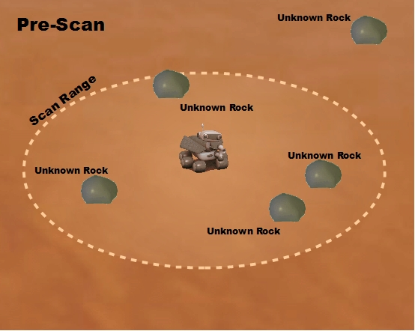

## 

### In Kodu

Scan functionality can be achieved using Kodu’s sound and listen features (they allow us to check for things in a radius), but we would likely want to create a scan tile as using the sound Kode is not intuitive for the students.

## Timer

The player will have a set amount of time (5 minutes but the time is tunable) to explore and inspect as many rocks as possible.

### In Kodu

Standard Kodu timers will work fine for this level.

## Layout

As in Level 3, the terrain will be designed to give clues to the player where to look for high value rocks.

* Sedimentary rock – ridges and cliff-like formations on the terrain have a higher chance of having Phyllosilicates.
* Craters – small depressions have a higher chance of containing Hematite.
* Flat – Contains mostly Lava Rocks

Rocks placement will vary to encourage different search parameters. Examples include:

* Low value rocks placed in bunches (do you prioritize going for many low value rocks?)
* High value rocks in isolated areas (do you go after a high value rock that is far away from other rocks?)

### In Kodu

Terrain types can be made by using Kodu’s materials. Unknown rocks in high value areas will be more likely to be high value rocks once scanned or bumped into.

# Game Flow

The student must program the Rover to score as many SVS points as possible. The Rover maximizes this by moving to areas with lots of rocks making sure to take into account terrain types where valuable rocks are likely to be.

Judicious use of scan will help the Rover to identify valuable rocks. Once identified, the Rover must choose which rocks to Inspect vs. which rocks to beam with the Laser.

## Programming the Rover

Students will need to program the following:

* Rover Movement Controls
* Activate Inspect Controls
* Activate Laser Controls
* Activate Scan Controls

Once in play the Player must choose which rocks to move to and how to inspect them.

The following actions occur:

* Bumping an unknown rock reveals its type
* Inspecting a rock scores double points (randomly determined, but higher value rocks score more points)
* Beaming a rock with the Laser scores points (randomly determined, but higher value rocks score more points)
* Scanning scores points and reveals rock types
* The experience ends when time runs out
  + We may add “Winner” conditions for certain score thresholds